1. 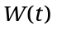is the amount of water (in ounces) in a pot t minutes after the water begins to boil.
Suppose W(2) = 30 and 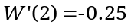

a. Give a sentence of practical interpretation for W(2) = 30 .

b. Give a sentence of practical interpretation for .

c. Find the percentage rate of change in the amount of water in the pot 2 minutes after the water begins to boil. Give units with your answer.

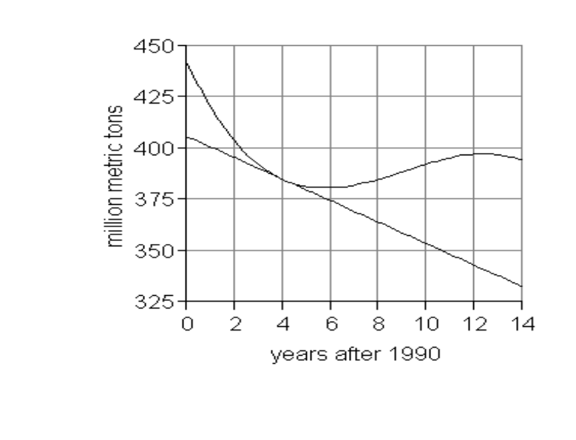
(2, 405)
(4, 384)
(8, 385)
(14, 334)
2. 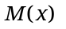depicts the world production
of milk (in million metric tons),
x years after 1990, 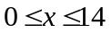.

a. Using a ruler, draw a line connecting the points at x = 2 and x = 8 on the graph. Find the slope of this line. Show all of your work.

b. Give your answer to (a) in a sentence of practical interpretation.
c. Find 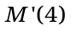. Show all of your work.

d. Give your answer to (c) in a sentence of practical interpretation.

3. The equation 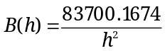 points describes the body-mass index (BMI) for women where h is a woman’s height in inches, 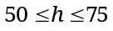. Checkpoint: B(51) = 32.180.

Use the Numerical Method to determine how quickly a woman’s BMI is changing when her height is 60 inches tall by completely filling out the table below.

Round table entries to FOUR decimal places.

Close points  To the left | Slope between 60 and Close Point | Close points  to the right | Slope between 60 and Close Point
59.9 | 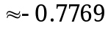

a. How quickly is a woman’s BMI changing when her height is 60 inches tall?

b. Find the percentage rate of change in the woman’s BMI when her height is 60 inches.

c. Write a derivative model for the function B(h):

4. Review the various types of change we have studied:

TYPES OF CHANGE | FORMULA | UNITS
CHANGE
PERCENT CHANGE
AROC
IROC
PROC

a. Fill in the second column of the table with the correct formula:

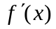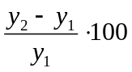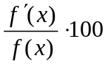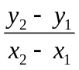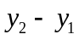

b. Fill in the third column of the table with the correct type of units:

Output units % Output units per input unit

Output units per input unit % per input unit

c. Write the type of change described in each sentence:

- In November 2006, the number of Facebook (unique) users was increasing by 2 thousand per month. ___________

- Between May 2006 and May 2007, the number of Facebook (unique) users increased by 89.4 %. ___________

- From May 2006 to May 2007, the number of Facebook (unique) users increased on average by 1.048 thousand per month. ___________

- Between May 2006 and May 2007, the number of Facebook (unique) users increased by 12.58 thousand. ___________

- In November 2006, the number of Facebook (unique) users was increasing by 12.5% per month. ___________

5. Find the derivative for each of the following functions. Use proper notation.
You will be penalized for incorrect use of “=” signs or for failure to use derivative notation for each derivative. If there is an algebraic transformation necessary, no credit will be awarded IF the transformation is not made.

a. 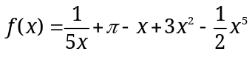 b. 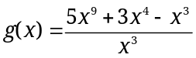

c. 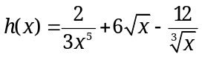 d. 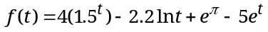

6. N(x) thousand gives the number of observed bacteria in a Petri dish, x hours after 8 am, between 8 am and 8 pm.

Use the fact that N(2) = 32.698 and the slope of the tangent line to N(x) at 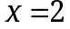 is 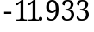, to find the percentage rate of change of N(x) at . Round your answer to three decimal places and include units with your answer.

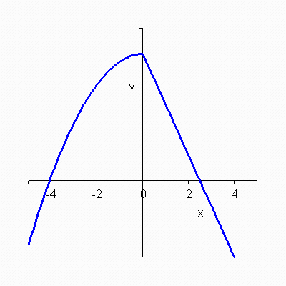
7. The graph of a function 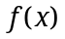 is given.

Which of the following is the graph of 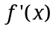?
a. b. c.
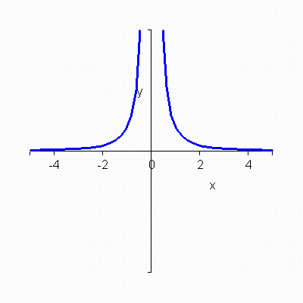
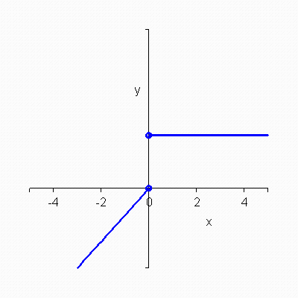
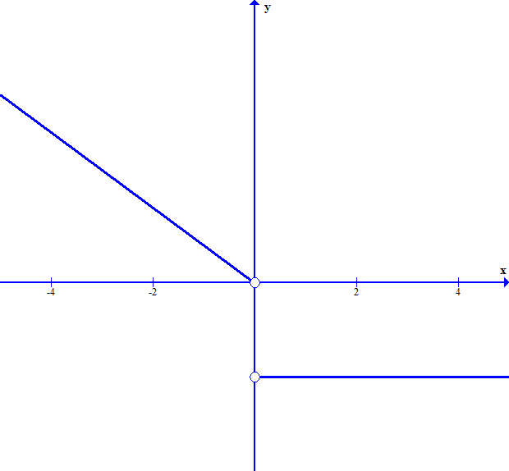

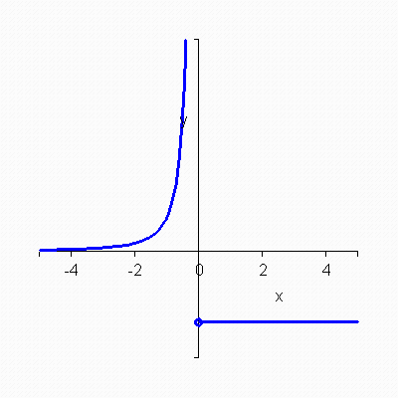
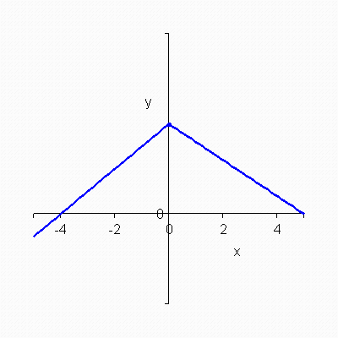
d. e.

8. The statements below refer to the graph of 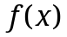given below. Which one of the following statements is true?
a. Line 1 is a tangent to. The slope of Line 1 gives the average rate of change of between point A and point C.

b. Line 2 is a secant on. The slope of Line 2 gives the average rate of change ofbetween point B and point D.

c. Line 1 is a secant on. The slope of Line 1 gives the instantaneous rate of change of at point C.

d. Line 2 is a secant on. The slope of Line 2 gives the instantaneous rate of change ofbetween point B and point D.
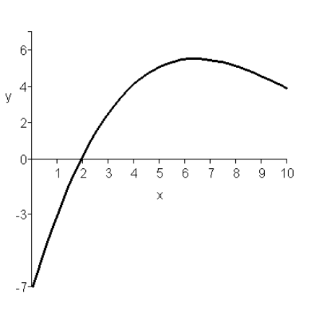
B
C
Line 1
Line 2
D

A
A
f(x)

9. When you use the Algebraic method (the limit definition) to find a derivative formula or value, you find 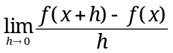. In this formula, what does the variable “h” represent, what does 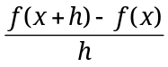represent, and what does the represent?

10. Given 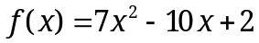. Show that 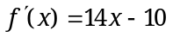 using the limit definition of the derivative. Show each distinct step and use proper mathematical notation in your work.

